**Project Design Phase**

**Technology Stack (Architecture & Stack)**

|  |  |
| --- | --- |
| **DATE** | 30 October 2023 |
| **TEAM ID** | PNT2022TMID05812 |
| **PROJECT NAME** | PROJECT-INDIAN FOOD EDA |
| **MARKS** | 4 MARKS |

**Technical Architecture:**

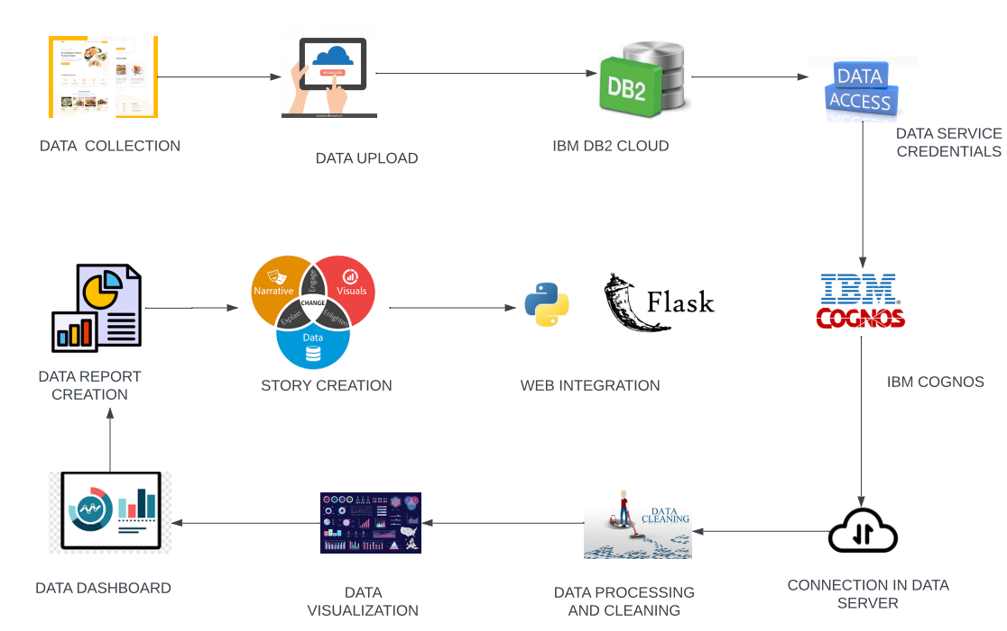

**Technology Stack:**

**Table-1: Components & Technologies:**

|  |  |  |  |
| --- | --- | --- | --- |
| **S.No** | **Component** | **Description** | **Technology** |
|  | User Interface | Web application for Exploratory Data Analysis (EDA) on Indian Food | HTML, CSS, JavaScript, Flask |
|  | Data Collection & Extraction from Database | Collect the dataset required for analysis. | IBM DB2, IBM Cognos |
|  | Data Preparation | Data preparation involves cleaning, transforming, and structuring collected data for analysis. | Python |
|  | Data Visualizations | Data visualizations to help users understand and explore the data. | IBM Cognos |
|  | Database | Data storage for managing and storing structured data. | IBM Cloud, IBM DB2 |
|  | Cloud Database | Cloud-based database for traditional databases, offering scalability and accessibility. | IBM DB2, IBM Cloud |
|  | File Storage | File storage is used for archiving and retrieving data files that may not fit into traditional databases. | IBM Cloud |
|  | External API-1 | External APIs are used to fetch additional data or services. | Graph QL API |
| 9. | External API-2 | External APIs are used to fetch additional data or services | Graph QL API |
| 10. | Machine Learning Model | Machine learning models are used to gain insights from data. | Python |
| 11. | Infrastructure (Server / Cloud) | provisioning and managing the infrastructure, including servers or cloud services | IBM Cloud, Flask |

**Table-2: Application Characteristics:**

| **S.No** | **Characteristics** | **Description** | **Technology** |
| --- | --- | --- | --- |
|  | Open-Source Frameworks | Flask framework for building web application | Python web frameworks like Flask web framework |
|  | Security Implementations | Security measures are essential to protect sensitive data and ensure data integrity. | IBM Cloud resources and IBM DB2 |
|  | Scalable Architecture | Essential to handle large datasets and accommodate future growth. | IBM Cloud Services, IBM Db2 on Cloud, and Flask Application |
|  | Availability | Availability ensures that EDA results and tools are accessible to stakeholders for data-driven decision-making. | IBM Cloud Services, Scheduled EDA Reports and Collaboration Platforms. |
|  | Performance | Performance optimization is essential for efficient data exploration and analysis. | IBM Db2 Optimization, Data Indexing and Parallel Processing. |